
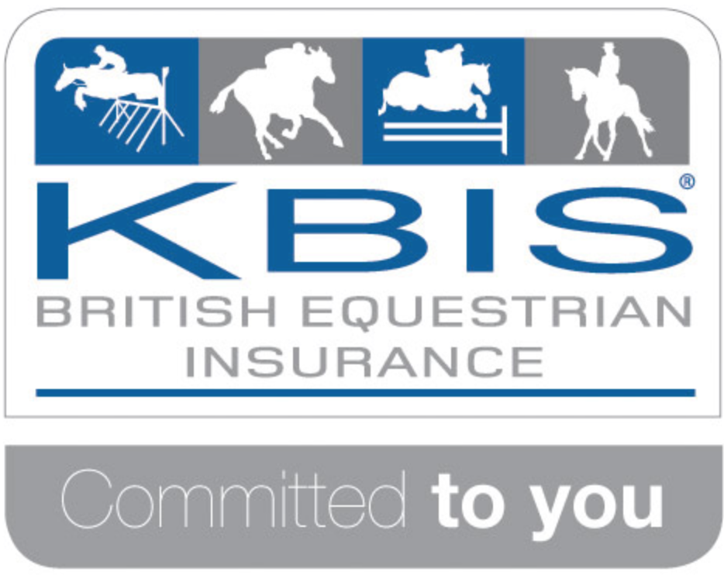
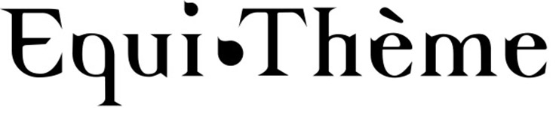
Frampton Family Riding Club

British Riding Clubs Area 9

JUNIOR & SENIOR
Winter Novice & Intermediate Show Jumping Team Qualifier
Incorporating an Intermediate Individual Qualifier
Sunday, 23rd October 2016
To be held in the Hartpury Arena at
Hartpury College, Hartpury, Gloucester GL19 3BE

Team entries only

Team rosettes to 6th place

Entry Fee: £76 per team (includes £2 medical fee per rider)
Cheques payable to ‘Frampton Family Riding Club’ please.

PRELIM ENTRIES DIRECT TO BRC CLOSE FRIDAY, 30th SEPTEMBER
AREA ENTRIES TO FFRC CLOSE FRIDAY, 14th OCTOBER
All entries must be made on the official British Riding Clubs Entry Form for the Winter Area Qualifiers.
Please ensure it is clear whether the team is competing in the Senior or Junior section.

ENTRIES & SHOW DAY CONTACT:
Delta Ferguson
4 Pineholt Gate, Hucclecote, Gloucester. GL3 3SQ
Email: delta.ferguson@gmail.com
Tel: 07969 449793

Please enclose photocopied vaccination records for all horses not on the Area database.
Alternatively email to area9vaccinations@outlook.com



***Show day photography by Mike Seal Photos***
***Onsite catering serving hot & cold food***

Start 08:30am

Class 1 – AREA 9 WINTER NOVICE TEAM SHOWJUMPING QUALIFIER
Teams consist of 3 or 4 riders. Each rider jumps two rounds (First round 80cm) the second round is timed and these times are used to determine minor placings when faults cannot do this. If there is equality for first place after the second round then there will be a jump off against the clock. The best three scores in each round will count for the total score. Teams must be either all Junior or all Senior members.

Riders not to have competed under FEI rules – CSI/CSIO/CDIW abroad (with exception of the European Championships – formerly Rural Riders) for 5 calendar years prior to the close of prelim entries

Open to horses and ponies with 0 BS points (other than notional points gained in 70cm & 80cm classes at BS Intro shows and any BS Club points), a maximum of 1 BE point (not to have been placed in the first 6 in a BE100 or above in the current or previous calendar year) and not to have competed in the Intermediate or Open Summer Showjumping Qualifiers in 2016. Horses competing in class 1 cannot compete in class 2.

Sash to winners and individual rosettes 1-6th in each section (Non-Qualifying) sponsored by B&W Equine. BRC Team rosettes 1-6th in each section
Class 1A – Junior Competition Class 1B – Senior Competition

Class 2 –AREA 9 WINTER INTERMEDIATE TEAM AND INDIVIDUAL SHOWJUMPING QUALIFIER (All Team Members eligible for Individual Qualifier)
Teams consist of 3 or 4 riders. Each rider jumps two rounds (First round 90cm) the second round is timed and these times are used to determine minor placings when faults cannot do this. If there is equality for first place after the second round then there will be a jump off against the clock. The best three scores in each round will count for the total score. Teams must be either all Junior or all Senior members.

Riders not to have competed under FEI rules – CSI/CSIO/CDIW abroad (with exception of the European Championships – formerly Rural Riders) for 5 calendar years prior to the close of prelim entries

Open to horses and ponies with a maximum of 500 BS points, 20 BE points and not to have competed in the Open Summer Showjumping Qualifiers in 2016. Horses competing in Class 2 cannot compete in class 1.

Sash to winners and individual rosettes 1-6th in each section (Highest placed junior and highest placed senior not in the winning teams to qualify). Team rosettes 1-6th in each section. Individual Winners Sashes kindly provided by B&W Equine

Class 2A – Junior Competition Class 2B – Senior Competition

Team start times will be available from Thursday, 20th October on:
www.brcarea9.org.uk & www.ffrc.org.uk

RULES AND CONDITIONS OF ENTRY

- All entries must be made on the official British Riding Clubs Entry Form for the Winter Area Qualifiers.
- The committee/landowner or anyone acting for these will not be held responsible for any loss/accident to persons, animal or property however caused.
- Owners and riders enter at their own risk.
- The judge’s decision and that of the official steward is final.
- Questions about the scoring must be made to the secretary. Objections and appeals to be made in writing, accompanied by a £10.00 deposit to the secretary within 10 minutes of the posting of the results of the class.
- This competition will run under British Riding Club Rules 2016.
- Vaccination Certificates: As stated in the rules, all BRC qualifying teams must be prepared to show their horse's passports and complete vaccination records on the day of the competition. Chef D’Equipes should ensure these are correct. Please send a copy of each horse’s flu vaccination record with the entries (unless already on Area database). Any incorrect certificates will result in exclusion from the qualifying competition.
- Entries will not be accepted without the correct fee. Cheques should be payable to ‘Frampton Family Riding Club’.
- In the event of withdrawals, the organisers regret that they cannot refund entry fees after the close of entries.
- Competitors must follow the instructions of stewards at all times.
- All horses and or ponies must be 4yrs or over.
- Only persons and/or horses competing may use the warm up facilities. Competitors may only warm up in the designated areas. Lunging is not permitted.
- Horses may not be left unattended tied to horseboxes or trailers.
- Competitors must wear the correct hats, dress and footwear as per BRC rules:
Hard hats must be worn and chin strap fastened by all riders when mounted, conforming to PAS015 (1998 or 2011) and must be BSI Kitemark OR ASTM F1163 (2004a or 04a) and must be SEI Mark OR Snell E2001 and must have Official SNELL label and number OR AS/NZS 3838 (2006) and must have SAI Global Mark. NO OTHER SPECIFICATION WILL BE PERMITTED.
All competitors must have a BRC Official ORANGE hat tag. Failure to do so will result in elimination.
- Health and Safety - The organisers of this event have taken reasonable precautions to ensure the health and safety of everyone present. For these measures to be effective everyone must take all reasonable precautions to avoid and prevent accidents occurring and must obey the instructions of the Organisers and Officials and Stewards.
- Legal Liability - Horse / pony sports can be dangerous, and animals are unpredictable. Neither the committee of Frampton Family Riding Club nor any person acting on their behalf, or the landowners can accept any liability for the loss, damage, accident or injury to any person or property. It is a condition of entry that each entrant agrees to indemnify the above persons against any legal action arising from such an incident.

All persons attending the show will be deemed to have accepted these rules and conditions.

