Cotswold Edge Riding Club

Area 9 Senior Novice Dressage, Pairs and Riding Test and Junior Dressage, Pairs, Elementary and Riding Test Qualifier.
Sunday June 24th 2012 at Manor Farm, Longney, Glos, GL2 3SL
By kind permission of Mr Richard Chapman

Tests for BRC Dressage Qualifier Classes

Senior Novice Dressage Team (Teams Only): Prelim 14 (2006)
Senior Riding Test Teams & Individuals: BRC RT 11 (2010) & BRC RT 13 (2010)
Senior & Junior Pairs: BRC Pairs 4 (2004)
Junior Dressage Teams & Individuals: Prelim 14 (2006) & Novice 27 (2007)
Junior Riding Test Teams & Individuals: BRC RT 11 (2010)
Junior Elementary Test (Individuals only): Elementary 42 (2008)

Dressage tests at Area Qualifiers may be commanded All tests and warming up will be on grass.

Rosettes 1st-6th place for all classes

Entry Fees: £44 per Team, £20 per Pair and £11 per Individual (includes Paramedic First Aid cover).
Please make cheques payable to CERC.

EVENT ENTRIES CLOSE (must be made on an official area entry form from BRC website): 14th June 2012.
Preliminary entries must be made directly to BRC at least 21 days before the qualifier date.

Note to Team Managers: Please make it clear on your entry forms which test each team member will be riding.

Vaccination certificates: As stated in the rules, all BRC qualifying teams must be prepared to show their passports and complete vaccination records on the day of the competition. Chefs D’Equipes should ensure these are correct. Please send a copy of each horse’s flu vaccination record with the entries.

Times: Please enclose a large SAE or an e-mail address for times. Times will also be available on www.cotswoldedgerc.co.uk from Thursday June 21st 2012.

Secretary: Sarah Carless, 21 Haddons Close, Malmesbury, Wiltshire, SN16 0JG
Telephone: (between 19.30 & 21.00 hours) 07917 771187
Email: sarah_carless@yahoo.co.uk
Mobile on the day: 07917 771187

Refreshments will be available on the day.

Directions to show venue

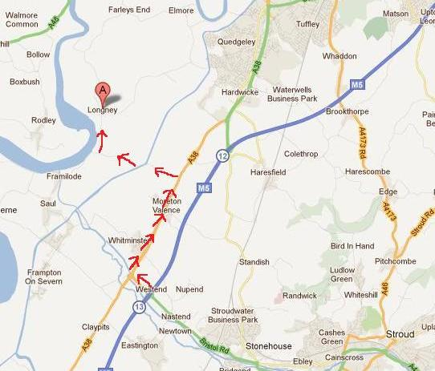

Exit M5 at J13 (Stroud). Travel on the A38 to the turning signed posted for Epney & Longney (Castle Lane). Travel along the road & go over the canal bridge. At the end of the road (in Epney) turn right at the T-juntion towards Longney & Elmore. Travel along the road and enter Longney. At the T-Junction Manor Farm will be in front of you. Turn left at the junction and follow road round. Car Parking will be indicated by the yellow CERC signs. Please park as directed by the stewards. Competitors are advised to leave plenty of time in which to arrive and warm up as a swing bridge is in operation over the canal and traffic can be held up as barges on the canal pass through.

RULES

- The competition will be run strictly under British Riding Club rules 2012.
- The judge’s decision and that of the Official Steward are final.
- Objections must be made to the Secretary in writing within 15 minutes of the end of the class and accompanied by a £10 deposit.
- All horses/ponies entered must have a vaccination record complying with BRC Rules. This must be brought on the day of the competition. Any incorrect certificates will result in that horse being excluded from competing.
- Entries will not be accepted without the correct entry fees. Cheques should be made payable to CERC.
- In the event of withdrawals, the organisers regret that they cannot refund entry fees after the close of entries.
- Competitors must follow the instructions of all stewards at all times. Failure to do so may result in elimination.
- Hats up to current standards with 3 point restraining harness MUST be worn and fastened at all times when mounted. Riders must present their hat for checking and tagging to the BRC Official Steward regardless of whether a BE or PC tag is also shown.
- All ridden horses/ponies must be 4 yrs or over.
- ONLY persons and/or horses competing may use the warm up facilities. Competitors may only warm up in the designated area. Lunging is not permitted.
- Horses may be tied to horseboxes or trailers but must NOT be left unattended.
- BRC health and safety guidelines apply at all times.
- Dogs must be kept on a lead at all times.
- Neither CERC, BRC Area 9 or Manor Farm will hold themselves responsible for any accident to persons, property and/or horses attending this show.
- All persons attending the show will be deemed to have accepted the rules and conditions.

Legal Liability
Save for death or personal injury caused by the negligence of the Organisers or anyone for whom they are in law responsible, neither the organisers of this event, nor any agent, employee or representative of these bodies or the land owner, his agent or representative, accepts any liability for any accident, loss, damage, injury or illness to horses ponies, owners, riders, spectators, land, cars their contents and accessories, or any other person or property whatsoever, whether caused by negligence, breach of contract or in any other way whatsoever.

Health and Safety
The Organisers of this event have taken reasonable precautions to ensure Health and Safety of everyone present. For these measures to be effective, everyone must take all reasonable precautions to avoid and prevent accidents occurring and must obey the instructions of the Organisers and all the officials and stewards.

