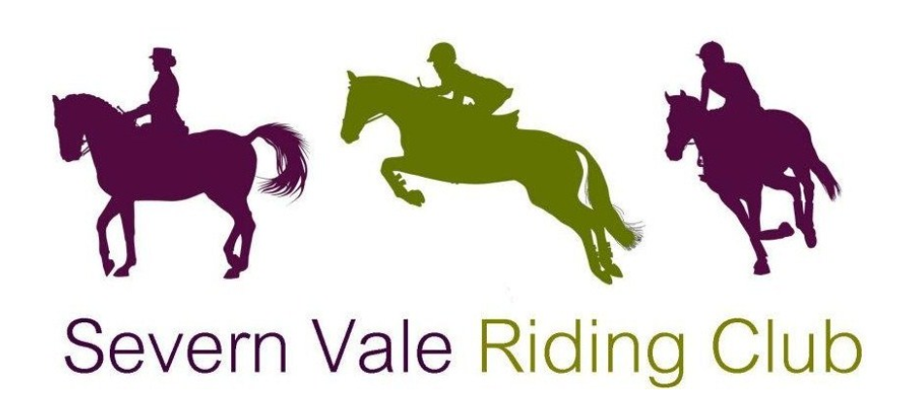

Area 9 BRC Senior Intermediate Dressage
(Including Individual Senior Medium/Advanced Medium Dressage)
Sunday 25th February 2024

Leyland Court Farm

Trench Lane, Winterbourne, Bristol BS361RY

By kind permission of Leyland Court Farm
Paramedics in attendance
Refreshments

Eligibility for all classes can be found in the current BRC Handbook. Eligibility will be taken from the Friday before the qualifier. All competitors must be a member and be on the BRC Database by the Friday before the qualifier. Anyone failing to meet the eligibility criteria will be disqualified and informed by BRC HQ when the results are processed.
Senior Intermediate Team Competition - 4 riders each ride a different test, Prelim 18 (2002), Novice 28 (2008), Novice 30 (2006) and Elementary 42 (2008).
Individual qualifier entries accepted.
The highest placed individuals in each section will also qualify for the Championships.

BRC Individual Winter Intermediate dressage competition –
PYO Medium 63 (2002) or Advanced Medium 90 (2012) Riders may enter both tests.

Championships date 27-28th April 2024 at Arena UK, Allington, Grantham
Numbers to qualify as per Appendix 10 in the current BRC Handbook.

Entry fee: Team £80 Individual £20
BACS: Severn Vale Riding Club
30 98 29 04108565

Prelim entries direct to BRC close: 4th February 2024
Area entries to SVRC close: 4pm 16th February 2024
(Entries on BRC Area Entry Form, available as Download from BRC website)

Secretary: Laura Prewett email: laurapru@yahoo.co.uk mob: 07487657606
Times will be available on the website from 18:00 20th February 2024

This competition will run under BRC Rules 2024, anyone in attendance will be bound by the BRC Code of Conduct. It is important that all competitors are aware of the rules relating to this competition – please see the current BRC Handbook and the BRC Rule Amendments and Changes Document which can be found at the link below: http://www.bhs.org.uk/enjoy- riding/british-riding-clubs/brc-rulebook.
All entrants must submit a pre-entry to BRC (fees can be found in the current BRC Handbook) at least 21 days before the date of the qualifier. Pre-entries can be made via the pre-entry website. Late pre-entries may be accepted at the discretion of the organiser with a late surcharge of £10 per individual (payable to BRC HQ) if space permits. Late entries cannot be guaranteed and so therefore must not be paid for until approval from the organiser has been gained.
Once the pre-entry has been made, an area entry must be made via the details outlined on this schedule.
If the date of the qualifier is cancelled for any reason and rescheduled within 21 days, the close of pre-entry will remain. If the qualifier is rescheduled for more than 21 days after the original date, entries will re-open. Late entry fees will not be refunded. Eligibility is taken from the Friday before the qualifier, regardless of rescheduling. Pre-entries that cannot attend the new date may be issued a credit note but the Team Manager must inform the office in writing before the cut-off date which the area will be informed of upon rescheduling.
Hats
All hats must have a visible Pink BRC/BE/PC hat tag in place before they are worn on the showground, to show that they meet the current safety standards. There will be a trained official available on the day to do this for you if your hat does not currently have one. For up-to-date hat rules please see the current BRC Handbook.
Flu Vaccinations
Your horse must have up to date influenza vaccinations in line with rule G7 in the current BRC Handbook. There is also a checking device on the BRC website. If you are unsure, please call BRC on 02476 840518.
Vaccination Records: Please email new or updated vaccination records and passport numbers to area9vaccinations@outlook.com

Kindly Sponsored by

General Rules

- The competition will be run strictly under British Riding Club rules 2024.
- ALL HORSES/PONIES ENTERED FOR BRC QUALIFIERS MUST HAVE A VACCINATION RECORD COMPLYING WITH BRC RULES, FOR MORE
INFORMATION, PLEASE GO HERE . IT IS THE RESPONSIBILITY OF THE CHEF D’EQUIPE TO ENSURE THESE ARE CORRECT.
ANY INCORRECT CERTIFICATES WILL RESULT IN THAT TEAM MEMBER’S
DISQUALIFICATION.
- Chefs D équipe should check the full BRC eligibility criteria for all horses and
riders.
- Declarations should be sent to the Secretary prior to the start of the Class.
- Alternatively, they may be emailed to the Area representative at
penpony@hotmail.com up to 6pm on the previous evening. Only simple changes to teams will be permitted once times have been posted (ie horse/rider replacing existing
position in a team).
- Entries will not be accepted without the correct entry fees. Clubs should send a single payment to: Severn Vale Riding Club 30-98-29 04108565
- In the event of withdrawals, the organisers regret that they cannot refund entry fees after the close of entries.
- Hats up to current standards with 3-point restraining harness MUST be worn and fastened at all times when mounted.
- All hats must have a BRC Pink coloured tag PRIOR TO RIDING in BRC qualifiers.
- BRC health and safety guidelines apply at all times.
- Neither SVRC, BRC Area 9 or Leyland Court EC will hold themselves responsible for any accident to persons, property and/or horses attending this show.
- The judge’s decision is FINAL.
- ONLY persons and/or horses competing may use the warmup facilities at Leyland Court
- All ridden horses/ponies must be 4 yrs or over.
- Objections to be made to the Secretary in writing within 10 minutes of the end of the class and accompanied by a £10 deposit.
- All persons attending the show will be deemed to have accepted the terms and conditions of the show.

LEYLAND COURT RULES

Please adhere to the following venue specific rules:

- Competitors are requested not to leave litter or muck out horse boxes in the box park, any droppings must be picked up.
- Horses must not be tied to horseboxes or trailers and left unattended
- No Haynets to be consumed outside of horseboxes or trailers

