Area 9 BRC Training
Cross Country jumping with Andrew Bennie
14th and 15th May, Boomerang Stables, Wantage RG177SD
Andrew is an Olympic Eventer, BE Accredited coach, BHSI and FEI International Eventing Judge
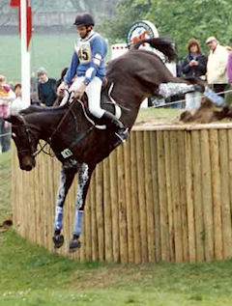

There will be 4 90 minute sessions on each day with a maximum 6 riders per group. Cost after Area subsidy will be £28 per rider. Groups will be graded from 80cm to 100+ based on horse/rider experience. There are ample jumps at all levels to meet everyone’s needs.
We will hold 4 places per club until April 17th, with a waiting list which will be allocated on a first-come first served basis if any of those places are not filled. We would ask that clubs give priority to members wishing to compete for the club.
Entry forms must be posted with an accompanying cheque, or emailed with confirmation of BACS payment (see below) to Carolyn Taylor, Northwood Farm, Swan Lane, Winterbourne, BS36 1RW,
with a cheque or BACS payment to Area 9 British Riding Clubs.(Santander, 09-01-28 08729283).Enquiries to Carolynjtaylor@icloud.com or 07771 902176.

In the event of withdrawal, the fee will not be refunded after May Ist unless the place is filled.

Application Form, XC Training. (to be completed by Club official)
Club:………………………………………….
Contact: Name…………………………… Tel……………………. email………………………………….
Rider 1
Name:_________________________Horse:____________________________
Email:____________________________ Mobile no._____________________
Availability: (please circle) Saturday/Sunday/either
Jumping level: (please circle) 80 / 80-90 /90 /90-100 /100-100+
Rider 2
Name:_________________________Horse:____________________________
Email:____________________________ Mobile no._____________________
Availability: (please circle) Saturday/Sunday/either
Jumping level: (please circle) 80 / 80-90 /90 /90-100 /100-100+
Rider 3
Name:_________________________Horse:____________________________
Email:____________________________ Mobile no._____________________
Availability: (please circle) Saturday/Sunday/either
Jumping level: (please circle) 80 / 80-90 /90 /90-100 /100-100+
Rider 4
Name:_________________________Horse:____________________________
Email:____________________________ Mobile no._____________________
Availability: (please circle) Saturday/Sunday/either
Jumping level: (please circle) 80 / 80-90 /90 /90-100 /100-100+

I enclose a cheque for £…………………. payable to Area 9 British Riding Clubs.
Or I have made a BACS payment (Santander, 09-01-28 08729283)
Signed____________________ Date___________________

