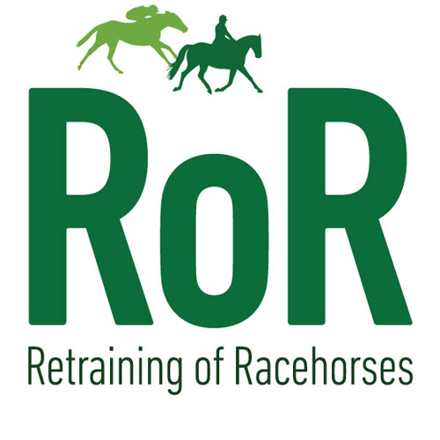
Area 9 Club Points.

Riders Full Name………………………………………………………………………………………………………………..

Horses Full Name …………………………………………………………………………………………………………………. This must be the passport / racing name.

ROR Membership Number …………………………………………………………………………………………………….. You must be a “Competition Member” to be eligible for Club Points.

Signed……………………………………………………………………………………………………………………………………….
Name ………………………………………………………………………………………………………………………………………..
Date …………………………………………………………………………………………………………………………………………..

By signing you are happy for Area 9 to hold your details on file to collect the information needed to award the yearly Championship trophy and rosette.

https://www.ror.org.uk/

